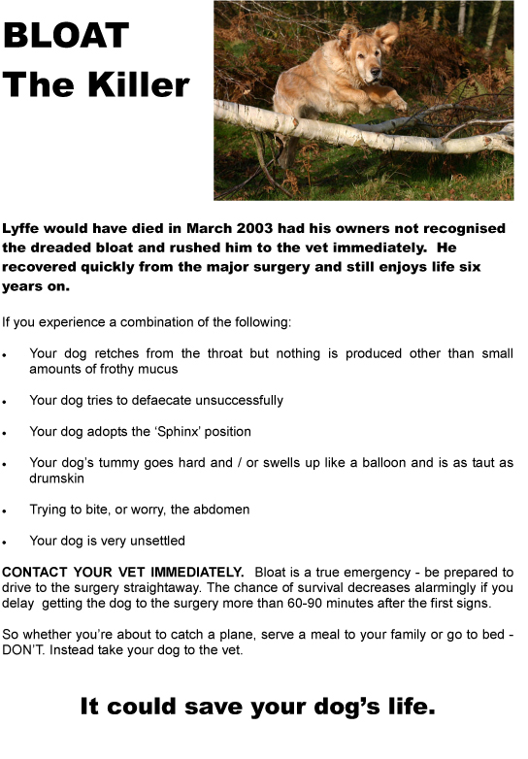
Please contact Brian Booth for a PDF of the poster for inclusion in puppy packs on Monbryth@aol.com

