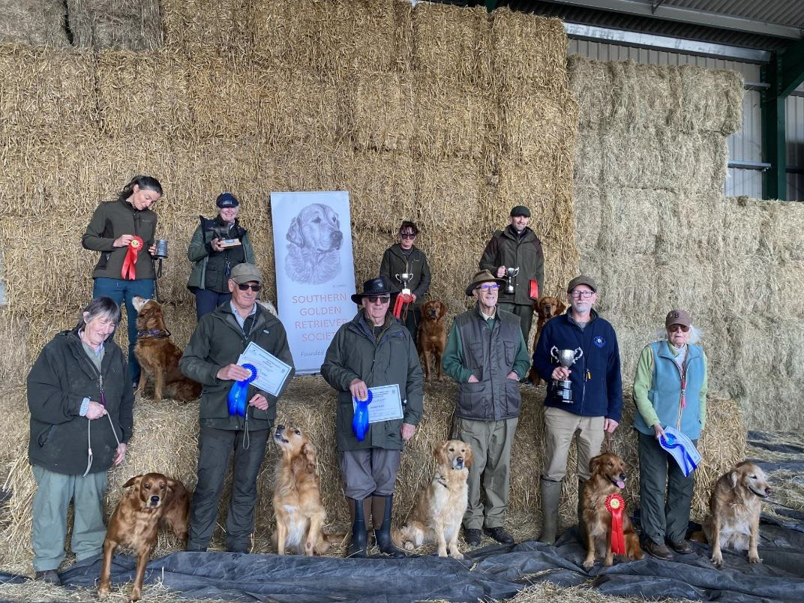
Southern Golden Retriever Society held their annual tests today April 12th at Five Oaks Farm Billingshurst thank you to the Morris family for allowing us to use their fabulous ground.
A big thank you to our judges Robert Worrall Colin Pelham Karen Handley and Lisa Murrell who ran the tests smoothly with the help of my amazing helpers who all received gifts from Gamekeepers Goods.
RESULTS:
SP/PUPPY 1st Lanlwyd Comanche handled by Laura Jayne Middleton ND/NH: 1st Kentwone Deep Lemon handled by Clare Waterman
2nd Rosgar Fruitophia handled by Neil Webb
NOVICE: 1st Quag's Quintessence Loyal Gold handled by Pawel Zygadlo 2nd Philchris Raep Rannock handled by Kevin Shaw
3rd Hanans Golden Treasure handled nay Anne Strachan OPEN: 1st Tullysedge Lone Star handled by Jon Debnam VET: 1st Auchencloch Fable handled by Edith Kreutner
2nd Polihale Bucks Fizz at Baveybuilt handled by Jean Baveystock
All award winners received Gamekeeper Goods and Skinner goodies and we thank them for the continuous support of the club. Well done to award winners - Sue Jordan WTS

